Chris Repanich

CECS 341

Lab 3: ALU & ALU_Control

**ALU:**

**Source Code:**

module ALU(A, B, ALU_Ctl, Zero_Flag, Output);

input [31:0] A, B;

input [3:0] ALU_Ctl;

output reg Zero_Flag;

output reg [31:0] Output;

always@(A, B, ALU_Ctl, Zero_Flag, Output)

begin

Zero_Flag <= 1'b0;

case(ALU_Ctl)

4'b0000://A & B

begin

Output <= A&B;

end

4'b0001://A | B

begin

Output <= A|B;

end

4'b0010://A + B

begin

Output <= A + B;

end

4'b0110://A - B

begin

Output <= A - B;

end

4'b0111://set on less than

begin

if (A<B)

Output <= 32'b1;

else

Output <= 32'b0;

end

4'b1100://nor

begin

Output <= ~(A|B);

end

default:

begin

Output <= 32'hXXXXXXXX;

Zero_Flag <= 1'bX;

end

endcase

if (Output == 0)

Zero_Flag <= 1'b1;

end

endmodule

**Screenshot:**

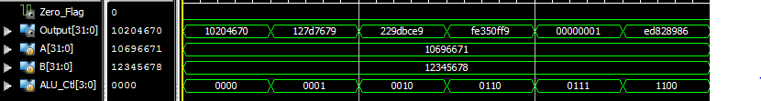

**ALU_Control:**

**Source Code:**

module ALU_Control(FuncCode, ALU_op, ALU_Ctl);

input [5:0] FuncCode;

input [1:0] ALU_op;

output reg [3:0] ALU_Ctl;

always@(FuncCode, ALU_op, ALU_Ctl)

begin

case(FuncCode)

6'b100000://ADD

begin

ALU_Ctl <= 4'b0010;

end

6'b100010://SUB

begin

ALU_Ctl <= 4'b0110;

end

6'b100100://AND

begin

ALU_Ctl <= 4'b0000;

end

6'b100101://OR

begin

ALU_Ctl <= 4'b0001;

end

6'b101010://SLT

begin

ALU_Ctl <= 4'b0111;

end

6'b100111://NOR

begin

ALU_Ctl <= 4'b1100;

end

6'bXXXXXX://Address Calculation, Equality Comparison

begin

if (ALU_op == 2'b00)

ALU_Ctl <= 4'b0010;

else

ALU_Ctl <= 4'b0110;

end

endcase

end

endmodule

**Screenshot:**

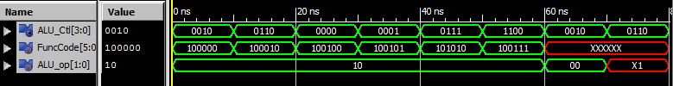

**ALU_Unit:**

**Source Code:**

module ALU_Unit(FuncCode, ALU_op, A, B, Zero_Flag, Output);

input [31:0] A,B;

input [5:0] FuncCode;

input [1:0] ALU_op;

wire [3:0] ALU_Ctl;

output Zero_Flag;

output [31:0] Output;

ALU_Control aluctl(FuncCode, ALU_op, ALU_Ctl);

ALU alu1(A,B,ALU_Ctl, Zero_Flag,Output);

endmodule

**Screenshot:**

